Aim: Denial of service (Dos) Attack:
Use Nemesy to launch a Dos Attack against a target system or network

Step 1: Open VMware->edit->Network Adapter->select NAT
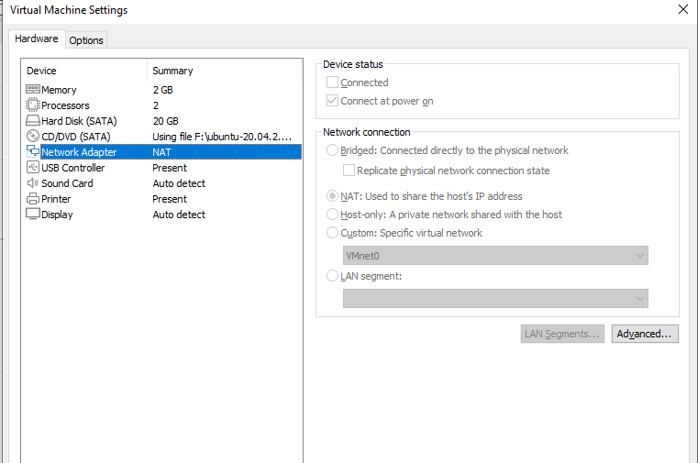

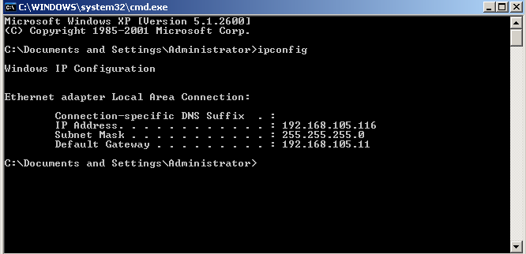
Step 2: Get Virtual Machine IP Address using Cmd:”ipconfig”

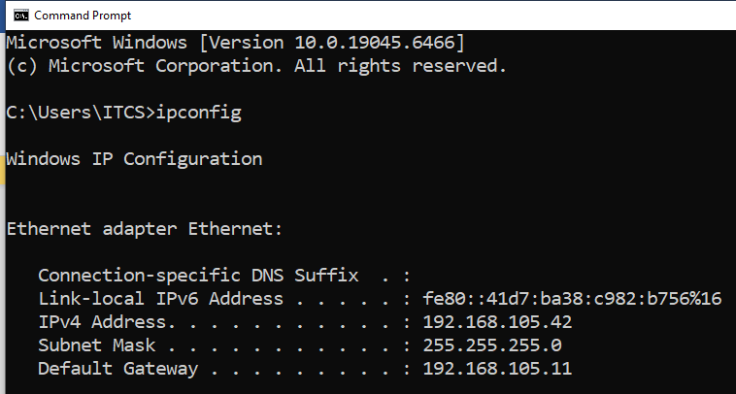
Step 3: Get Host Machine IP Address using cmd:”ipconfig”

Step 4: Check Connectivity between Virtual Machine and Host Using Ping Command
vice versa for Host To Virtual Machine
Host to Virtual Machine
- Command: “ping ip address of virtual machine -t -l 65500”
Virtual To Host Machine
- Command: “ping ip address of virtual machine -t -l 65500”
Ping Effect: From host to virtual machine
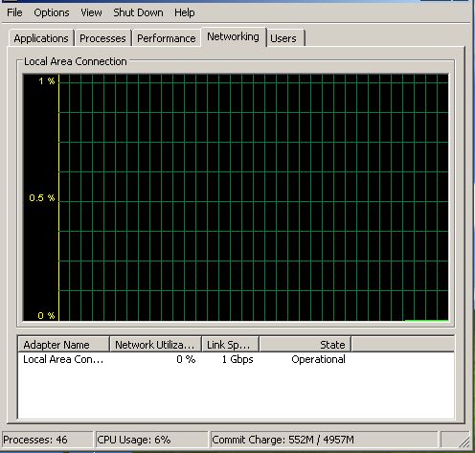

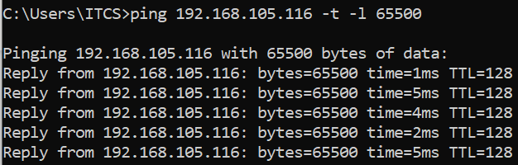

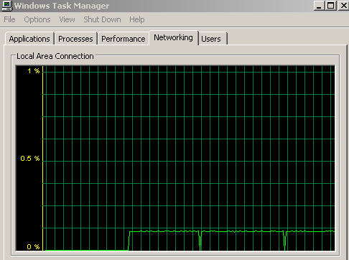

Ping Effect : From Virtual Machine to Host
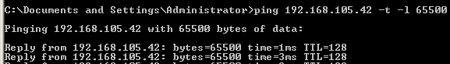

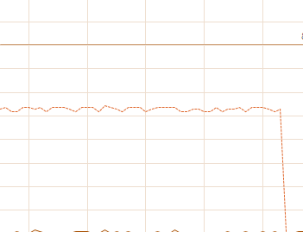

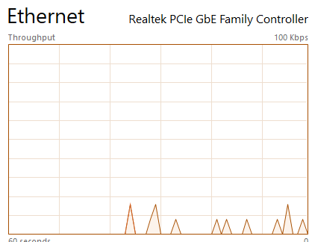

Step 5: Dos Attack Using Nemesy Tools
- From Virtual Machine To Host Machine
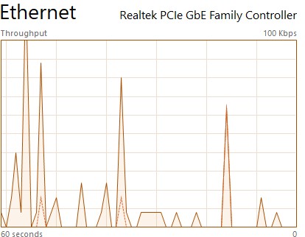
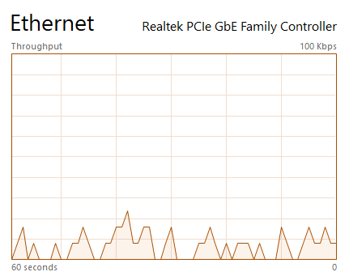

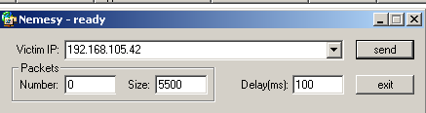

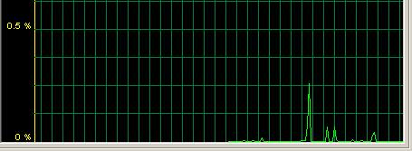
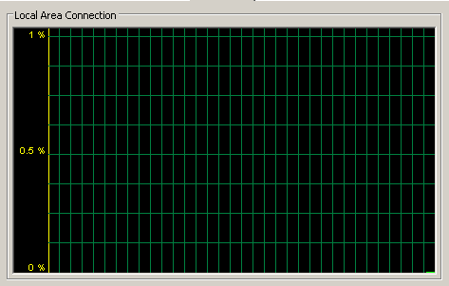
- From Host Machine To Virtual Machine

